Chapter 17, Solution 11.

Obtain the exponential Fourier series for the signal in Fig. 17.54.

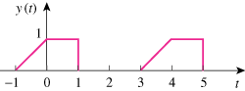

10

Figure 17.54
For Prob. 17.11.

Solution

But

y(t) = $$\sum_{n=-∞}^{∞}{\frac{5}{n^{2}π^{2}}}\left[2-2\cos{(}nπ/2)-2j\sin{(}nπ/2)+jnπ\cos{(}nπ/2)+nπ(\sin{(}nπ/2))\right]e^{jnπt/2}$$

